**Instruction Guide**

Thank you for purchasing Barking-Up-The-Wrong-Tree, Ireland’s choice in Bark-Stopping Gadgetry.

To set up your Device - please remove it from it’s packaging. Your device comes pre-assembled like the below image (just imagine the device is a small square box with a camera opening and a cable for power):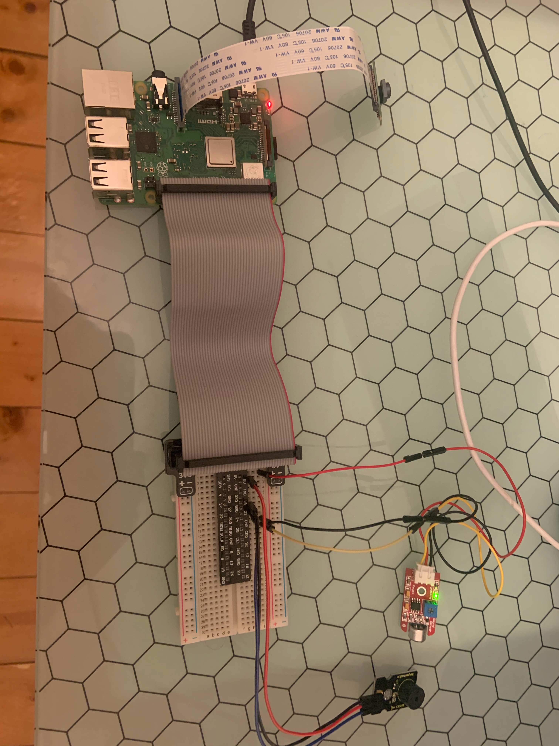

Connect your Device to power and place it where the camera will be most likely to capture the catalyst of your dog’s barking (I suggest near the front window - dogs barking at the postman is a cliche for a reason).

Your WebApp and Twitter Feed have been pre-created and assigned to your device before shipment. Please go to <https://twitter.com/CDWIT1> and click the follow button then the Account Notifications Button (Bell) - Be sure to set it to”All Tweets” to ensure you receive an alert each time your dog starts barking. (For reference the alert website for your device is [dogbarkingalertweb.glitch.me](http://dogbarkingalertweb.glitch.me)).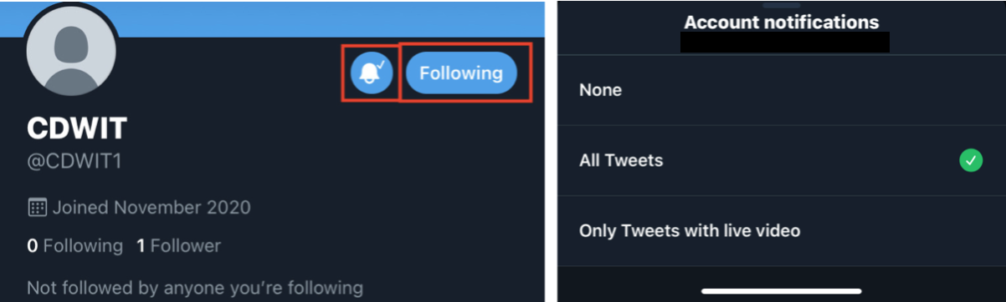

That’s it. You’re ready to go! When your dog starts barking a shrill tone will play which your dog will find distracting dissuading them from continuing to bark. Simultaneously, a Photo will be taken by your Camera displaying the reason for your dog barking, a timestamp will be taken and an alert will be triggered causing you to receive a notification your dog has begun barking. If you click on the attached link you’ll see the photo taken.